**BONUS POINTS -­ Communicating Analytical Insights**

The attached dashboard was produced by the Wall Street Journal and aims to provide readers with an overview of the performance of U.S. stocks, bonds, currencies and commodities. While this dashboard was found online it appears to be an extract from a hard copy of the Wall Street Journal weekend newspaper for the period from 9-10 May 2015.

This dashboard aims to convey a variety of information to readers on a single page. While there are no obvious concerns with respect to the underlying data and analytical models used to produce the dashboard, it does make several of the ‘thirteen common mistakes in dashboard design’ identified by Few (2013). Notable design mistakes include:

* *Displaying excessive detail or precision:* Data on the dashboard is far more precise than necessary which results in ‘information overload’ for the reader. For example, the ‘current divisor’ in the extract below does not need to be provided to a precision level of 13 decimal places.

Figure 1: Example of displaying excessive detail or precision

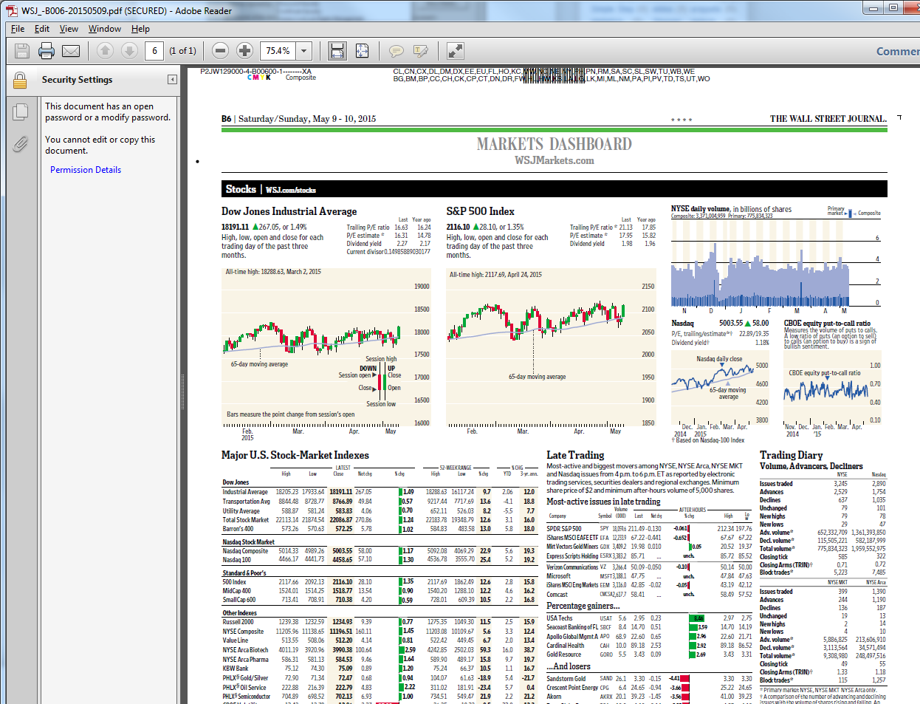

* *Displaying data using inappropriate media*: some of the charts on the dashboard are so small that they are near impossible to interpret accurately, as evidenced by Figure 2 below.

Figure 2: Example of displaying data using inappropriate media

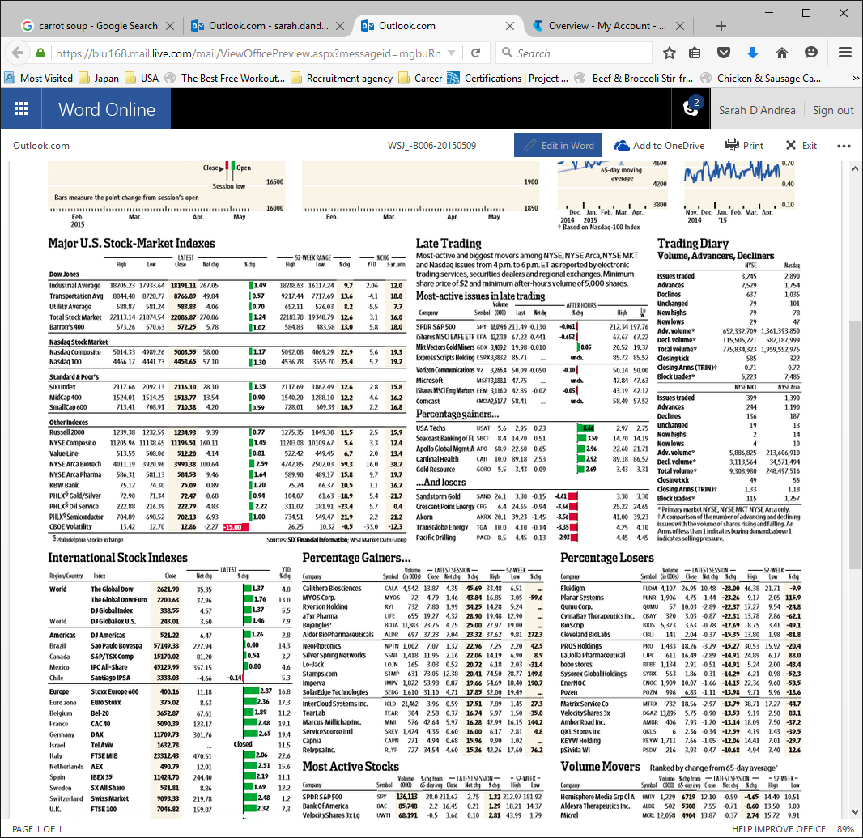

* *Highlighting important information ineffectively or not at all*: The reader is immediately drawn to look at the stocks section of the dashboard given its placement and that it is the most visual section of the dashboard. This detracts from information that may be very important in the ‘bonds, rates & yields’ or ‘currencies & commodities’ sections.

While it has several weaknesses, the dashboard does the following well:

* All information is presented in a single page, enabling the reader to easily compare the presented data.
* Comparisons are made to previous months or years, providing the reader with context when interpreting the data (see Figure 3 below).

Figure 3: Example of providing the reader with context when interpreting the data

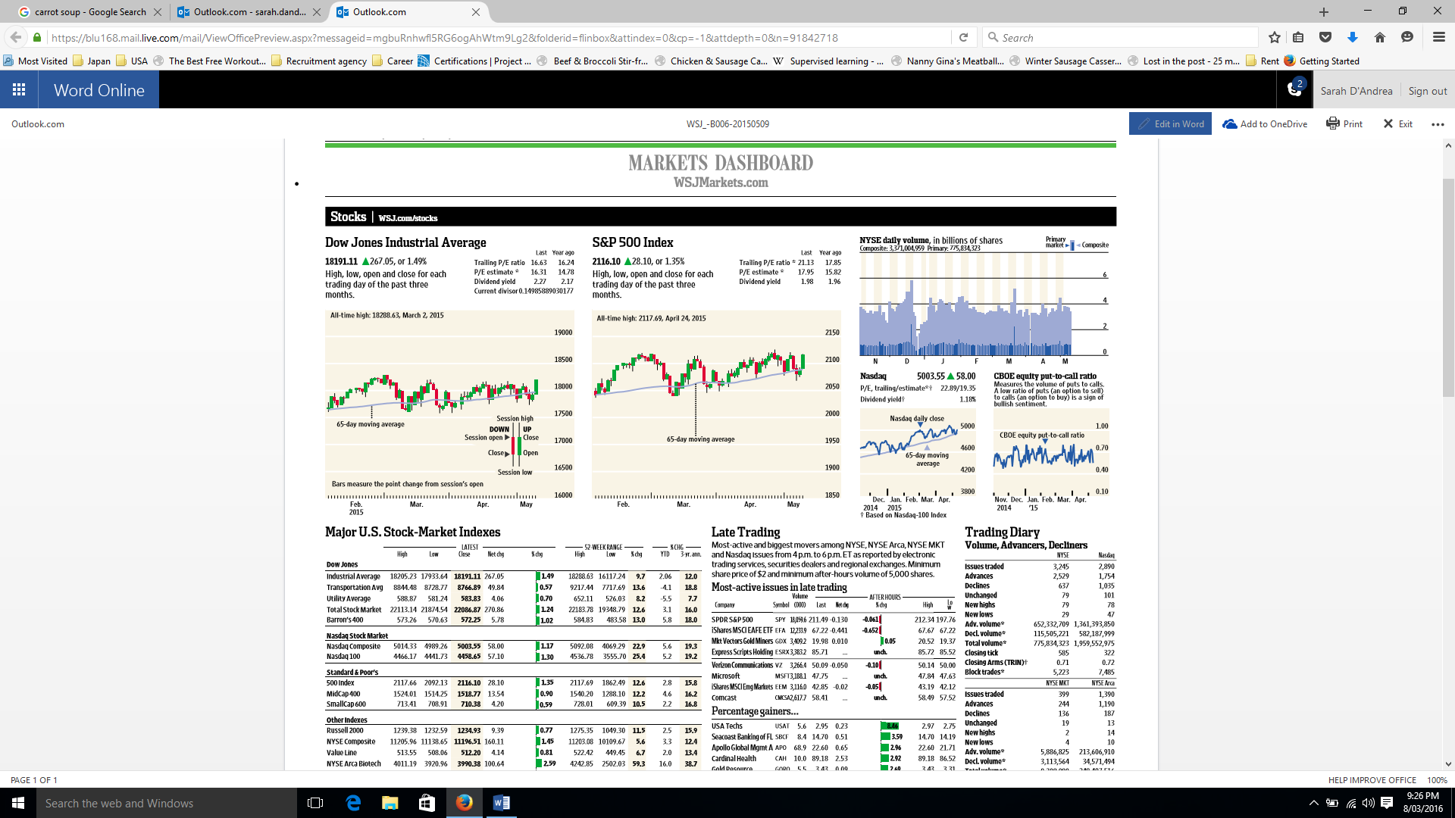

* Variety was used appropriately. The authors used color only when it enhanced the meaning of the data (e.g. green for positive result, red for negative result) and were not afraid to use the most appropriate chart, even if the style of chart had been used elsewhere in the dashboard.

Given the breadth of content in this dashboard, I would suggest that the Wall Street Journal conducts research with readers to determine which elements of the dashboard are essential and which can be removed. It is questionable whether the level of detail provided is necessary to provide the reader with an overview of market performance.